Project Design Phase-II
Data Flow Diagram & User Stories

Date | 31 January 2025
Team ID | LTVIP2026TMIDS39006
Project Name | TransLingua – AI-Powered Multi-Language Translator
Maximum Marks | 4 Marks

1. Data Flow Diagram (DFD)
A Data Flow Diagram (DFD) visually represents how data flows within the TransLingua system. It shows how data enters the system, how it is processed, and how it is returned to the user.
In the TransLingua application:
- The user provides input text and selects languages.
- The system processes the input.
- The request is sent to Google Gemini AI.
- The translated output is returned and displayed.
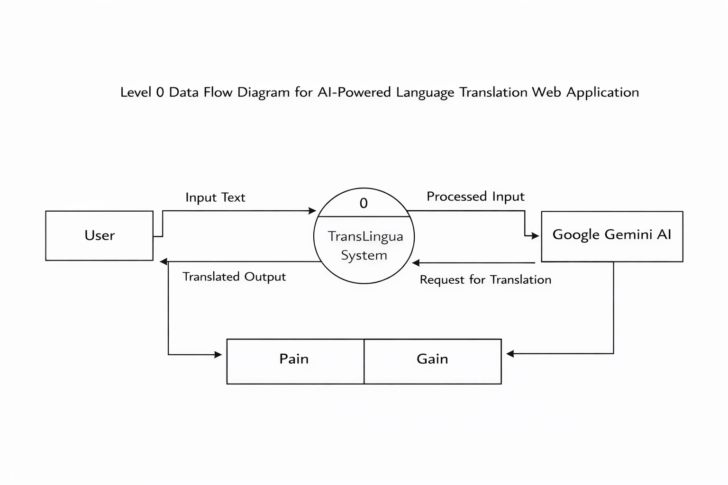

2. User Stories
User stories describe system functionality from the user’s perspective. They help define requirements clearly and guide development.

User Type | Functional Requirement (Epic) | User Story Number | User Story / Task | Acceptance Criteria | Priority | Release
Customer (Web User) | Text Translation | USN-1 | As a user, I can enter text to be translated. | The system accepts text input without errors. | High | Sprint-1
Customer (Web User) | Language Selection | USN-2 | As a user, I can select source and target languages. | Language dropdowns are displayed and selectable. | High | Sprint-1
Customer (Web User) | AI Translation | USN-3 | As a user, I can generate translated text using AI. | The system returns accurate translated output. | High | Sprint-1
Customer (Web User) | Output Display | USN-4 | As a user, I can view translated text instantly. | The translated text appears without delay. | High | Sprint-1
Administrator | API Key Security | USN-5 | As an administrator, I can securely manage API keys. | API key is stored in .env and not exposed. | High | Sprint-1
Administrator | Version Control | USN-6 | As a developer, I can maintain project code in GitHub. | Code is stored with proper repository structure. | Medium | Sprint-1
User Type | Functional Requirement (Epic) | User Story Number | User Story / Task | Acceptance Criteria | Priority | Release
Customer (Web User) | Text Translation | USN-1 | As a user, I can enter text to be translated. | The system accepts text input without errors. | High | Sprint-1
Customer (Web User) | Language Selection | USN-2 | As a user, I can select source and target languages. | Language dropdowns are displayed and selectable. | High | Sprint-1
Customer (Web User) | AI Translation | USN-3 | As a user, I can generate translated text using AI. | The system returns accurate translated output. | High | Sprint-1

